**CHAPTER 1 Introduction to Computers and Programming 1**

Main Hardware Component Categories:

1. Central Processing Unit (CPU)

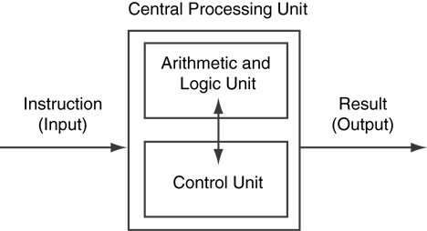

1. Main Memory
2. Secondary Memory / Storage
3. Input Devices
4. Output Devices

Categories of software:

* 1. System software: programs that manage the computer hardware and the programs that run on them. *Examples*: operating systems, utility programs, software development tools

Operating Systems

An operating system is the most fundamental set of programs on a computer. The operating system controls the internal operations of the computer s hardware, manages all the devices connected to the computer, allows data to be saved to and retrieved from storage devices, and allows other programs to run on the computer.

Utility Programs

A utility program performs a specialized task that enhances the computer's operation or safeguards data. Examples of utility programs are virus scanners, file-compression programs, and data-backup programs.

Software Development Tools

The software tools that programmers use to create, modify, and test software are referred to as software development tools. Compilers and integrated development environments, which we discuss later in this chapter, are examples of programs that fall into this category.

* 1. Application software: programs that provide services to the user. *Examples* : word processing, games, programs to solve specific problems

From a High-Level Program to an Executable File

1. Create file containing the program with a text editor.
2. Run preprocessor to convert source file directives to source code program statements.
3. Run compiler to convert source program into machine instructions.
4. Run linker to connect hardware-specific code to machine instructions, producing an executable file.

* Steps b–d are often performed by a single command or button click.
* Errors detected at any step will prevent execution of following steps.

